**C Variables**

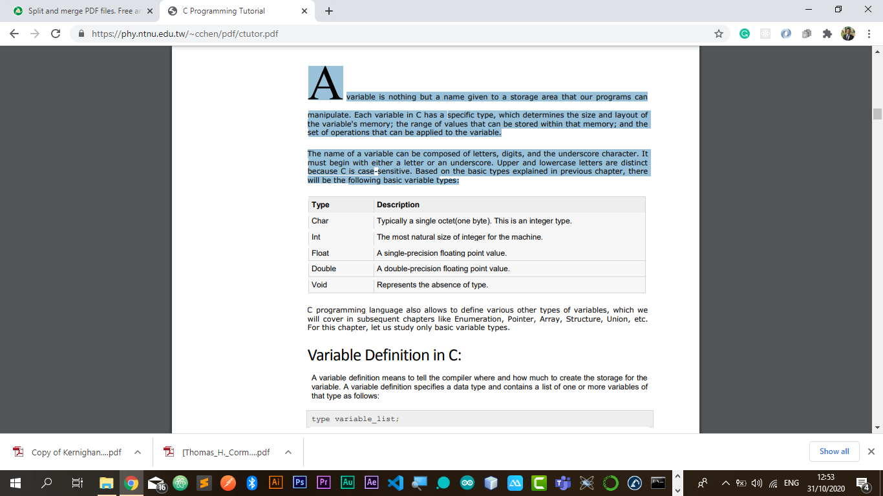 A variable is nothing but a name given to a storage area that our programs can manipulate. Each variable in C has a specific type, which determines the size and layout of the variable's memory; the range of values that can be stored within that memory; and the set of operations that can be applied to the variable. The name of a variable can be composed of letters, digits, and the underscore character. It must begin with either a letter or an underscore. Upper and lowercase letters are distinct because C is case-sensitive. Based on the basic types explained in previous chapter, there will be the following basic variable types:

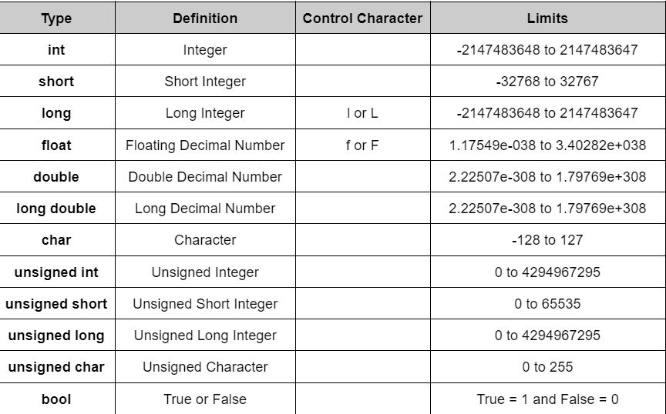

C++ programming language also allows to define various other types of variables, which we will cover in subsequent chapters like Enumeration, Pointer, Array, Structure, Union, etc. For this chapter, let us study only basic variable types.

**Variable Definition in C++**:

A variable definition means to tell the compiler where and how much to create the storage for the variable. A variable definition specifies a data type and contains a list of one or more variables of that type as follows:

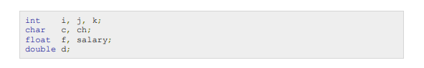Here, type must be a valid C++ data type including char, w_char, int, float, double, bool or any userdefined object, etc., and variable_list may consist of one or more identifier names separated by commas. Some valid declarations are shown here:

The line int i, j, k; both declares and defines the variables i, j and k; which instructs the compiler to create variables named i, j and k of type int. Variables can be initialized (assigned an initial value) in their declaration. The initializer consists of an equal sign followed by a constant expression as follows:



Some Examples are:

**Variable Declaration in C++**: A variable declaration provides assurance to the compiler that there is one variable existing with the given type and name so that compiler proceed for further compilation without needing complete detail about the variable. A variable declaration has its meaning at the time of compilation only, compiler needs actual variable declaration at the time of linking of the program. A variable declaration is useful when you are using multiple files and you define your variable in one of the files, which will be available at the time of linking of the program. You will use extern keyword to declare a variable at any place. Though you can declare a variable multiple times in your C++ program but it can be defined only once in a file, a function or a block of code.

**Example**

Try the following example, where variables have been declared at the top, but they have been defined and initialized inside the main function:

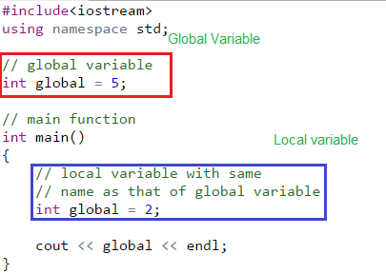

**Numeric Expressions**

|  |  |
| --- | --- |
| **Operation** | **Operator** |
| Addition | + |
| Subtraction | - |
| Multiplication | * |
| Division | / |
| Remainder | % |

**Character constants**

Character literals are enclosed in single quotes, e.g., 'x' and can be stored in a simple variable of char type. A character literal can be a plain character (e.g., 'x'), an escape sequence (e.g., '\t'), or a universal character (e.g., '\u02C0'). There are certain characters in C when they are preceded by a backslash they will have special meaning and they are used to

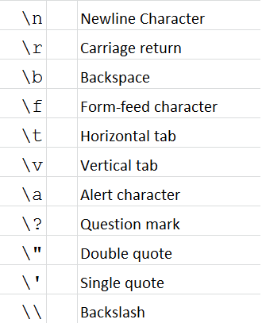represent like newline (\n) or tab (\t). Here, you have a list of some of such escape sequence codes: